Ex no: 23 | Implementing relationships using Sqlalchemy
Date : | Implementing relationships using Sqlalchemy

Question:1
Design an ORM for the given UML class diagram and also perform the following operations
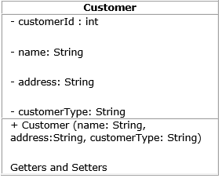

Create sequence for the customerId as 'seq_cust_id' starting with 5001. This field should be primary key .
2. Create and save 5 customer details.
3. Display the first record
4. Update the address of any customer .
5. Display customerId, name and customerType of all the customers.
6. Delete any two person from the table

Aim::
To Design an ORM for the given UML class diagram and also perform the following operations

Code::
from sqlalchemy.ext.declarative import declarative_base
from sqlalchemy import *
from sqlalchemy.orm import *
from sqlalchemy import exc
Base = declarative_base()

class customer(Base):
__tablename__ = "customers"
cust_id = Column(Integer, Sequence('seq_cust_id', start=5001), primary_key=True)
name = Column(String(25))
address = Column(String(35))
customer_type= Column(String(20))
# Constructor
def __init__(self,cust_id,name,address,customer_type):
self.cust_id=cust_id
self.name = name
self.address = address
self.customer_type = customer_type
# Getters
def get_id(self):
return self.cust_id
def get_name(self):
return self.name
def get_address(self):
return self.address
def get_type(self):
return self.customer_type
# Setters
def set_id(self, value):
self.cust_id = value
def set_name(self, value):
self.name = value
def set_address(self, value):
self.address = value
def set_type(self, value):
self.customer_type = value
def __repr__(self):
return f"CUSTOMER ID = {self.get_id()}\nNAME = {self.get_name()}\nADDRESS = {self.get_address()}\nCUSTOMER TYPE = {self.get_type()}"

Session = sessionmaker()
engine=create_engine("oracle://mk:1@localhost:1521/XE")
Base.metadata.create_all(engine)
session = Session.configure(bind=engine)
session = Session()
li=[]
print('Enter Five id ')
for i in range(5):
li.append(input())
li1=[]
print('Enter Five Name ')
for i in range(5):
li1.append(input())
li2=[]
print('Enter Five address ')
for i in range(5):
li2.append(input())
li3=[]
print('Enter Five Customer type ')
for i in range(5):
li3.append(input())
obj=customer(li[0],li1[0],li2[0],li3[0])
obj1=customer(li[1],li1[1],li2[1],li3[1])
obj2=customer(li[2],li1[2],li2[2],li3[2])
obj3=customer(li[3],li1[3],li2[3],li3[3])
obj4=customer(li[4],li1[4],li2[4],li3[4])
session.add(obj)
session.add(obj1)
session.add(obj2)
session.add(obj3)
session.add(obj4)
session.commit()
#3
print('First Record')
print(session.query(customer).first())
session.commit()
print(session.query(customer).all())
#4
print('Update the address of any customer .')
session.query(customer).filter_by(name=li1[0]).update({customer.address:'Covai'})
session.commit()
qry=session.query(customer).all()
print(qry)

print('Display customerId, name and customerType of all the customers.')
qry=session.query(customer.cust_id,customer.name,customer.customer_type).all()
print(qry)
print("Delete any two person from the table ")
session.query(customer).filter_by(name=li1[0]).delete()
session.query(customer).filter_by(name=li1[0]).delete()
session.commit()
qry=session.query(customer).all()
print(qry)
session.close()

Output

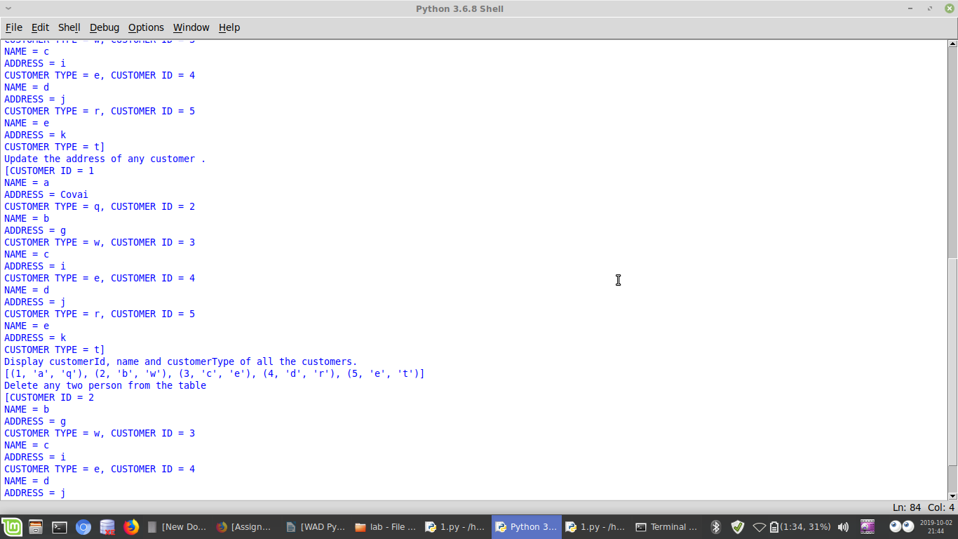

Result:
Thus web page has been successfully Implemented relationships using Sqlalchemy
Ex no: 23 | Implementing relationships using Sqlalchemy
Date : | Implementing relationships using Sqlalchemy

Question:2
Create a model class based on the one to many relationship given in the UML class diagram below and Insert all the details into the database using SQLAlchemy.
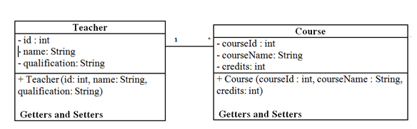

Aim:
To Create a model class based on the one to many relationship given in the UML class diagram below and Insert all the details into the database using SQLAlchemy.

Code:
from sqlalchemy.ext.declarative import declarative_base
from sqlalchemy import *
from sqlalchemy.orm import *
from sqlalchemy import exc
Base = declarative_base()
class Teacher(Base):
__tablename__ = "teachers"
id = Column(Integer, Sequence('author_id_seq'), primary_key=True)
name = Column(String(50))
qualification=Column(String(50))
course_id=Column(Integer)
course_name=Column(String(50))
course_credit=Column(Integer,primary_key=True)
course= relationship("Course", back_populates="teacher")
class Course(Base):
__tablename__ = "course"
c_id = Column(Integer)
c_name = Column(String(50))
credits1= Column(Integer, ForeignKey('teachers.course_credit'))
author = relationship("Author", back_populates="book")
def __repr__(self):
return("Course_id={}/nCourse_name={}/nCredits={}".format(self.c_id,self.c_name,self.credits1))
Session = sessionmaker()
engine=create_engine("oracle://mk:1@localhost:1521/XE")
Base.metadata.create_all(engine)
session = Session.configure(bind=engine)
session = Session()
obj=Teacher(1,'mk','be',12,'som',13)
obj1=Course(199,'Mukesh')
session.add(obj)
session.commit()
#print(session.query(Author).all())
print(session.query(Book).all())

Output:

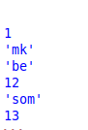

Result:
Thus web page has been successfully Implemented relationships using Sqlalchemy

Ex no: 24 | Developing web application using Flask-SQLAlchemy
Date : | Developing web application using Flask-SQLAlchemy

Question:1
Develop a web application for managing the Author details.
(i)Design a web page using HTML to read the Author details such as authorId,firstName and lastName.
(ii)Create a model class based on one to one relationship given in the UML class diagram below and Insert all the details into the database using Flask-SQLAlchemy.

Aim:
To Develop a web application for managing the Author details.

Code:
from flask import *
from flask_sqlalchemy import *
from sqlalchemy import *

app = Flask(__name__)
app.config['SQLALCHEMY_DATABASE_URI'] = 'oracle://mk:1@localhost:1521/xe'
app.config['SQLALCHEMY_TRACK_MODIFICATIONS'] = True
db = SQLAlchemy(app)

class user97(db.Model):
__tablename__ = 'mk1'
id =db.Column(db.Integer,db.Sequence('seq_book',start=1001),primary_key=True)
f_n= db.Column(db.String(80))
l_n = db.Column(db.String(120))
title= db.Column(db.String(80))
b= db.Column(db.String(80))

@app.route("/")
def index():
return render_template("login.html")
@app.route("/register", methods=["GET", "POST"])
def register():
if request.method == "POST":
a= request.form['f_name']
b= request.form['l_name']
c= request.form['hi']
d=request.form['ti']
register = user97(f_n=a,l_n=b,title=d,b=c)
db.session.add(register)
db.session.commit()
return render_template("wel.html")
if __name__ == "__main__":
db.create_all()
app.run(debug=True)
INDEX.HTML
<!DOCTYPE html>
<html>
<head>
</head>
<body>
<form method="POST" action="/register">
<p>First Name</p>
<p>
<input type='text' name='f_name' />
</p>
<p>Last name</p>
<p>
<input type='text' name='l_name' />
</p>
<p>Book Id</p>
<p>
<input type='text' name='hi' />
</p>
<p>Title</p>
<p>
<input type='text' name='ti' />
</p>
<button type="submit" >Submit</button>
</div>
</form>
</body>
</html>

Output:

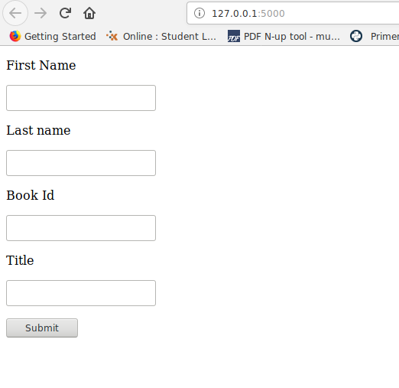

Result:
Thus we successfully Developed the web application using Flask-SQLAlchemy
Ex no: 24 | Developing a webpage using javascript
Date : | Developing a webpage using javascript

Question:2
Write a JavaScript program that displays the position of the first occurrence of "World" in the
variable txt

Aim:
To Write a JavaScript program that displays the position of the first occurrence of "World" in the
variable txt

Code:
from flask import *
from flask_sqlalchemy import *
from sqlalchemy import *

app = Flask(__name__)
app.config['SQLALCHEMY_DATABASE_URI'] = 'oracle://mk:1@localhost:1521/xe'
app.config['SQLALCHEMY_TRACK_MODIFICATIONS'] = True
db = SQLAlchemy(app)
class user97(db.Model):
__tablename__ = 'mk2'
id =db.Column(db.Integer,db.Sequence('seq_book',start=1001),primary_key=True)
Name = db.Column(db.String(80))
Address = db.Column(db.String(120))
Phone= db.Column(db.String(80))
@app.route("/")
def index():
return render_template("register.html")
@app.route("/register", methods=["GET", "POST"])
def register():
if request.method == "POST":
uname = request.form['uname']
mail = request.form['mail']
passw = request.form['passw']
register = user97(Name= uname,Address= mail,Phone= passw)
db.session.add(register)
db.session.commit()
return render_template("wel.html")
if __name__ == "__main__":
db.create_all()
app.run(debug=True)

INDEX.HTML:
<!DOCTYPE html>
<html>
<head>
</head>
<body>
<form method="POST" method="POST" action="/register">
<p>Name</p>
<p>
<input type='text' name='uname' />
</p>
<p>Address</p>
<p>
<input type='text' name='mail' />
</p>
<p>PhoneNumber</p>
<p>
<input type='text' name='passw' />
</p>
<input type = "submit" value = "Submit">
</div>
</form>
</body>
</html>

Output:

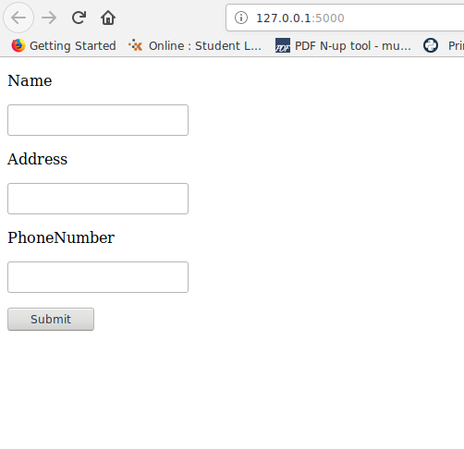

Result:
Thus we successfully Developed the web application using Flask-SQLAlchemy
Ex no: 24 | Developing a webpage using javascript
Date : | Developing a webpage using javascript

Question:3
Design the following web page using Flask-SQLAlchemy:

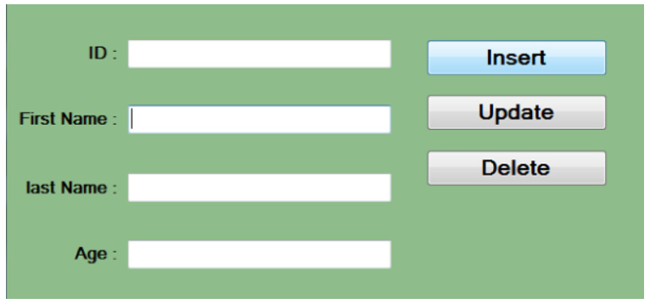

Aim:
To Design the following web page using Flask-SQLAlchemy:

Code:
from flask.app import Flask
from flask.globals import request
from flask.templating import render_template
from flask_sqlalchemy import SQLAlchemy
app = Flask(__name__)
app.config['SQLALCHEMY_DATABASE_URI']='oracle://mk:1@localhost:1521/XE'
db=SQLAlchemy(app)
class Book(db.Model):
__tablename__ = 'books_tbl'
id =db.Column(db.Integer,db.Sequence('seq_book',start=1001),primary_key=True)
title=db.Column(db.String(25))
price=db.Column(db.Float)
author=db.relationship("Author",back_populates='book')
def __repr__(self):
return f"<Book(title={self.title},price=Rs.{self.price},author={self.author})>"
class Author(db.Model):
__tablename__='authors_tbl'
id = db.Column(db.Integer,db.Sequence('seq_author',start=5001),primary_key=True)
name=db.Column(db.String(20))
bookid = db.Column(db.Integer,db.ForeignKey('books_tbl.id'))
book = db.relationship("Book",back_populates='author')
def __repr__(self):
return f"<Author(name={self.name})>"
@app.route('/')
@app.route('/book',methods=['GET','POST'])
def book_store():
if request.method=='GET':
return render_template('bookstore.html')
elif request.method=='POST':
title=request.form['title']
author_name=request.form['author']
price=request.form['price']
option=request.form['option']
if option=='Add':
author=Author(name=author_name)
book=Book(title=title,author=[author],price=price)
db.session.add(book)
db.session.commit()
elif option=='Update':
book=Book.query.filter(Book.title==title).one()
book.price=price
db.session.commit()
elif option=='Delete':
book=Book.query.filter(Book.title==title).one()
db.session.delete(book)
db.session.commit()
else:
books=Book.query.all()
return render_template('show.html',books=books)

return render_template('bookstore.html')
if __name__=="__main__":
db.create_all()
app.run(debug=True)

Output

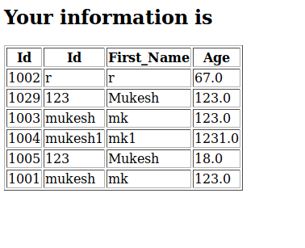

Result:
Thus we successfully Developed the web application using Flask-SQLAlchemy.

